EXPERIMENT NO. 3 / 4
Project Scheduling Using PERT/CPM and Gantt Chart
Project: Hospital Management System (HMS)
Prepared by: Anish Chitnis (24CE1044) | Aaryan Choube (24CE1045) | Somansh Dafade (24CE1047)
Batch: A / A1 | Dept of Computer Engineering, RAIT, DY Patil University
1. Aim
To use project management scheduling techniques (PERT/CPM) to determine activity durations, compute float, establish the Critical Path, and draw the Gantt Chart for the Hospital Management System (HMS).
2. Objectives
• To decompose the HMS project into 11 discrete work breakdown activities (A to K).
• To construct an Activity-on-Node (AON) network and perform Forward Pass and Backward Pass computations.
• To determine Earliest Start (ES), Earliest Finish (EF), Latest Start (LS), Latest Finish (LF), and Total Float (TF) for all activities.
• To identify the Critical Path and draw a comprehensive Gantt Chart representing the 47-day development schedule.
3. Activity Breakdown & CPM Computations
Act | Description | Pred | Dur | ES | EF | LS | LF | Total Float | Critical?
A | Requirement Analysis | - | 5 | 0 | 5 | 0 | 5 | 0 | YES (Critical)
B | SRS IEEE 830 Prep | A | 4 | 5 | 9 | 5 | 9 | 0 | YES (Critical)
C | System Design (DFD/UML) | B | 6 | 9 | 15 | 9 | 15 | 0 | YES (Critical)
D | DB Design & Schema | C | 5 | 15 | 20 | 15 | 20 | 0 | YES (Critical)
E | UI/UX Wireframing | C | 8 | 15 | 23 | 21 | 29 | 6 | NO (Float = 6d)
F | Patient & Appt Module | D | 9 | 20 | 29 | 20 | 29 | 0 | YES (Critical)
G | Doctor Consult & EHR | D | 8 | 20 | 28 | 21 | 29 | 1 | NO (Float = 1d)
H | Pharmacy & Lab Module | F | 7 | 29 | 36 | 31 | 38 | 2 | NO (Float = 2d)
I | Billing & Payment Module | F | 9 | 29 | 38 | 29 | 38 | 0 | YES (Critical)
J | System Integration & Test | I | 6 | 38 | 44 | 38 | 44 | 0 | YES (Critical)
K | Deployment & Training | J | 3 | 44 | 47 | 44 | 47 | 0 | YES (Critical)

4. Critical Path Analysis
• Minimum Total Project Duration = 47 Days.
• Critical Path Sequence: A ➔ B ➔ C ➔ D ➔ F ➔ I ➔ J ➔ K
• Managerial Implication: Any slippage in critical activities (A, B, C, D, F, I, J, K) will directly delay the final delivery of the project. Non-critical activities (E, G, H) possess slack float that can absorb minor scheduling delays without affecting the 47-day deadline.
5. Gantt Chart Representation
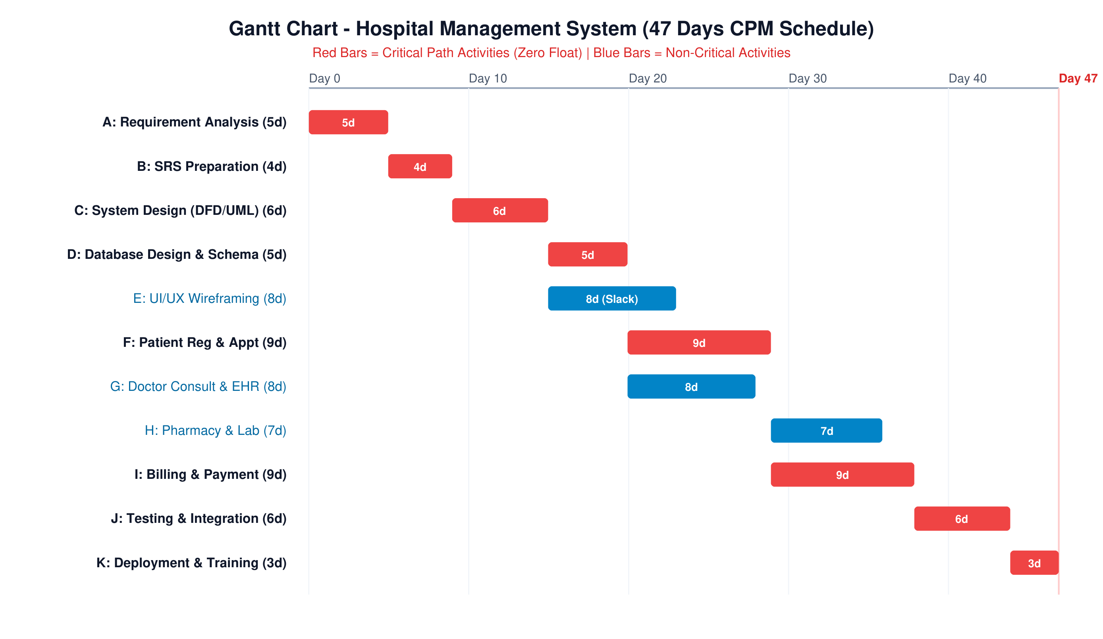
Fig 1: Gantt Chart - Hospital Management System (47 Days CPM Schedule)
6. Conclusion
The PERT/CPM analysis establishes an optimal schedule of 47 working days for the Hospital Management System. The Gantt chart provides a clear visual baseline for monitoring development velocity and mitigating schedule risks.

